Verb

🔴 What is a Verb?
# Source: Chatgpt (GPT-4-turbo) at [7/24/2025]
A verb is a word that shows an action, a state, or an occurrence. It tells what the subject does, is, or feels.

📘 Definition:
# Source: Chatgpt (GPT-4-turbo) at [7/24/2025]
A verb is a word that expresses what is happening in the sentence — either an action (e.g., run), a state (e.g., be), or an event (e.g., happen).

🧠 Examples of Verbs:
# Source: Chatgpt (GPT-4-turbo) at [7/24/2025]
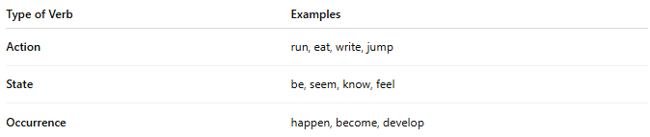
Type of Verb | Examples
Action | run, eat, write, jump
State | be, seem, know, feel
Occurrence | happen, become, develop

✳️ Types of Verbs:
# Source: Chatgpt (GPT-4-turbo) at [7/24/2025]
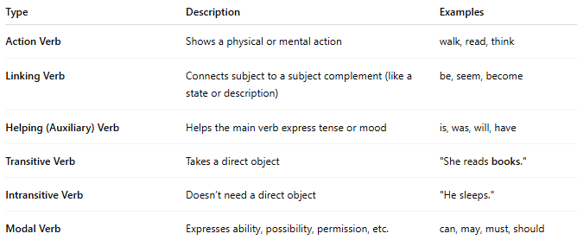
Type | Description | Examples
Action Verb | Shows a physical or mental action | walk, read, think
Linking Verb | Connects subject to a subject complement (like a state or description) | be, seem, become
Helping (Auxiliary) Verb | Helps the main verb express tense or mood | is, was, will, have
Transitive Verb | Takes a direct object | "She reads books."
Intransitive Verb | Doesn’t need a direct object | "He sleeps."
Modal Verb | Expresses ability, possibility, permission, etc. | can, may, must, should

🧾 Verbs in Sentences:
# Source: Chatgpt (GPT-4-turbo) at [7/24/2025]
- She runs every morning. (action verb)
- They are happy. (linking verb)
- I have eaten dinner. (helping + main verb)
- It rains a lot here. (intransitive verb)
- She wrote a letter. (transitive verb)

🔄 Verb Tenses (brief examples):
# Source: Chatgpt (GPT-4-turbo) at [7/24/2025]
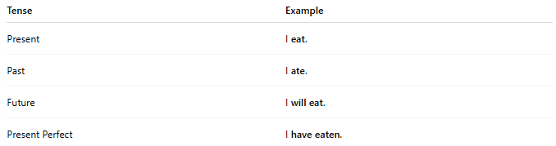
Tense | Example
Present | I eat.
Past | I ate.
Future | I will eat.
Present Perfect | I have eaten.

✅ Summary:
# Source: Chatgpt (GPT-4-turbo) at [7/24/2025]
A verb is the heart of the sentence. It tells us what is happening or what the subject is.

